January 17, 2014
Contact trade press
Thomas Lange
Manager Communications
High Performance Polymers
Telefon +49 2365 49-9227
Telefax +49 2365 49-809227
thomas.lange2@evonik.com

Evonik Industries AG
Rellinghauser Straße 1-11
45128 Essen
Germany
Phone +49 201 177-01
Fax +49 201 177-3475
www.evonik.com
www.vestakeep.com

Supervisory Board
Dr. Werner Müller, Chairman
Executive Board
Dr. Klaus Engel, Chairman
Thomas Wessel
Patrik Wohlhauser
Ute Wolf
Registered office Essen
Registered court
Essen local court
Commercial registry B 19474
VAT ID no. DE 811160003

New suture anchor made of VESTAKEEP® PEEK

With the development of the knot-free Plug-n-Twist suture anchor, IST Innovative Shoulder Technology AG and Argomedical AG have created another addition to their successful product portfolio. For the first time, the new suture anchor was made from VESTAKEEP® PEEK from Evonik Industries. Plug-n-Twist anchors are impact anchors for the second row in minimally-invasive arthroscopic sutures on the shoulder’s rotator cuff.

In addition to a titanium version, the anchor is now also available in the same product design in a version made of PEEK, a non-resorbable plastic. The use of the new anchor does not require any changes to intraoperative procedures. The long suture threads of the first medial anchor row are pulled through the eyelet in the tip of the Plug-n-Twist anchor and are then fixed in place using the anchor's pressure against the bone. In the so-called interference procedure, the suture threads used for repairing the defect are tightly fitted between bone and anchor for a permanent press fit. Thanks to the rounded tip of the implant, there is significantly less soft tissue irritation when the anchor is inserted in the shoulder.

The innovative design of the Plug-n-Twist anchor allows it to be easily inserted and, if necessary, removed by means of unscrewing.

"PEEK has proven successful as an implant material. It is biocompatible and ideally suited for medical imaging procedures because it does not generate any artifacts," says Dr. Christoph Sternberg of Etzelclinic in Pfäffikon (Switzerland). "Another advantage of using PEEK as an anchor material is its easy handling in any later revision surgery, in case the anchor is severed with a bone saw and has to be removed."
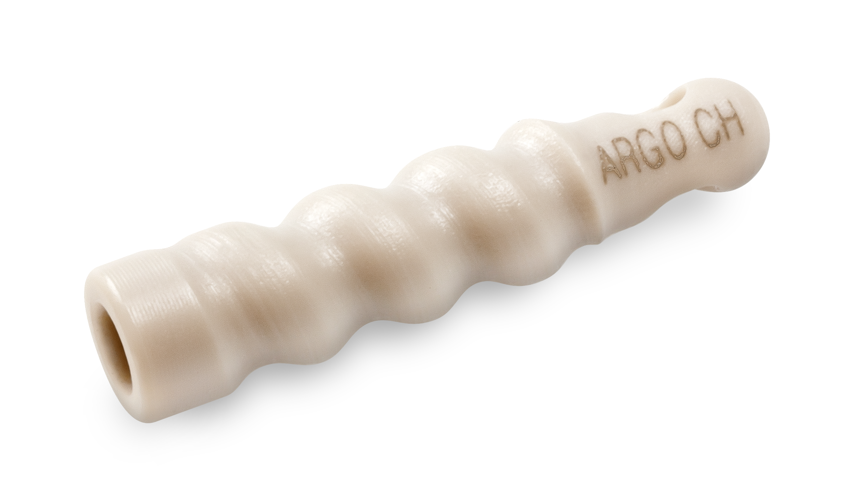

Image Caption:
The new suture anchor made of PEEK

About Evonik
Evonik, the creative industrial group from Germany, is one of the world leaders
in specialty chemicals. Profitable growth and a sustained increase in the value of the company form the heart of Evonik’s corporate strategy. Its activities focus on the key megatrends health, nutrition, resource efficiency and globalization. Evonik benefits specifically from its innovative prowess and integrated technology platforms.

Evonik is active in over 100 countries around the world. In fiscal 2012 more than 33,000 employees generated sales of around €13.4 billion and an operating profit (adjusted EBITDA) of about €2.4 billion (excluding Real Estate in both cases).

About Argomedical
Argomedical has been engaged in the development, production, and marketing of high-quality products for orthopedics and traumatology since 1989. A committed management and a well formed, enthusiastic team have created an environment that is perfect for stake holders and customers.
In collaboration with recognized, multidisciplinary specialists we have developed solutions and enabled a large number of operators to use our products.

About IST Innovative Shoulder Technology
IST was founded in 2005 in view of the developments in the Swiss health care market. At the time of the flat rate payment system, it seemed essential to develop a product series that would allow for high quality treatment at more reasonable prices.

Disclaimer
In so far as forecasts or expectations are expressed in this press release or where our statements concern the future, these forecasts, expectations or statements may involve known or unknown risks and uncertainties. Actual results or developments may vary, depending on changes in the operating environment. Neither Evonik Industries AG nor its group companies assume an obligation to update the forecasts, expectations or statements contained in this release.

